Colonialism in The United States of America
` The move by The ton Hall University to embrace the application of art as an effective tool pays a major role in bringing out the theme of colonialsm in the America history. Its dedication and commitment has an extensive exploitation of how an American culture is passed from one generation to another through artifacts preserved in various galleries. This paper will focus on some of them as shown on the exhibition checklist.
The Portrait of George Washington After the Battle of Princeton
The portrait of Gorge Washington after the battle of Princeton created by Charles Wilson Peale in 1779 plays a significant role in the American history. He painted the portrait with an objective of commemorating the triumphs of the Continental army at Princeton, Trenton, and New Jersey. To facilitate deep understanding of the history, Peale went ahead producing numerous replicas to enhance distribution to a large group. The portrat indicates a general located unedr the American flag with Hessian banners seized at Trendon scattered around his feet. Besides, the portrait depics American army in the background leading the captured British prisoners of war of the field. Moreover, Washington wears a blue ribbon across his breast as indicated in the initial portrait to display him as the emblem of the commander-in-chief of the armed forces since 1775. However, Washington changed the military regalia by replacing the blue sash with three silver stars on the epaulettes to indiate the history America got over the British. This portarit communicates a lot regarding the certain period in the history of the American military operation.
The Portrait of Mrs.
The fascinating aspect about the portrait manifest through beauty of the silkdress worn by Mrs. Scot and the larvish blister necklace that lays on her neck. They act as a symbol of wealth owned by her husband. John Singleton Copley uses her image to depit the status of her husnband in the American history. However, she never owned any of the dress as thought to be currently. The image plays arole of indicating the English aristocratic history. The portrait indicates the American interests in the colonial history. Some of them narated to Copley the way the portrait should look like. For instance the portatriat of Mrs Scot indicates the aristocratic power as brough out in the history. How aristocratic leaders enjoyed powere as shown by the posture and the luxurious mode of dressing applied by Mr. Scot. The idea indicated explores the interest of how the Anglo American was built on trade and accomplishment rather traditions than aristocracy
The War Spirit at Home: Celebrating the Battle at Vicksburg
The portrait has the image of mothers with their children celebrating after the war of Vicksburg. It is approximately 44 years old according to the American history. It is found at the Newark Museum in the United States of America. The portrait indicates the unreality of the war as the children turn with turn into the game with the sober reflection of the mothers and the housemaids who remain aware of the horrors brought by war at the end of the battle. Copley tries to cultivate the idea that the wars during the American colonialism led to more suffering of women and children in the society. However, from the ground, children and their mothers seem to be happy because the war is over
Portrait of Elizabeth Allen Stevens
The portrait was done by John Singleton Copley

The portrait was done by John Singleton Copley. Elizabeth Allen died with 83 years. She was known to be a member of the Presbyterian faith. She was the Club direct with the US army. Her portrait brings out the role of women in the American war. It brings out the idea of the struggle of women towards liberating America
Collections from the Video
Use of ancient dhows by use guys like Christopher Columbus across Pacific Ocean. The voyages led to discovery of America. These voyages resulted to American colonization where Churches replaced the temples. The video also addresses Island people living in the forest who use trees to make canoes. The video shows some of the artifacts of Indians digging gold and silver
Conclusively, American society has extensively used artefacts to preserve its culture and history. It uses artists to use the skills of art to create a visual impression of its history. Artefacts are also used to promote American talents.

Check List
The Portrait of George Washington After the Battle of Princeton
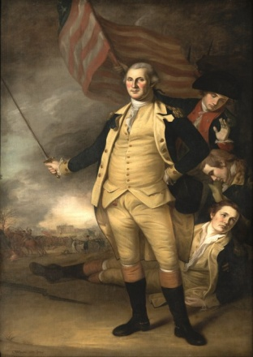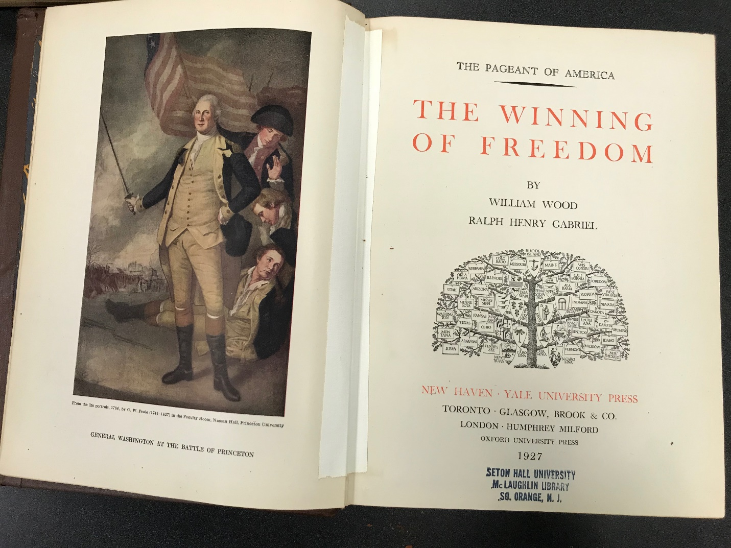
Details
- Title: Portrait of George Washington after the battle of Princeton
- Creator: Charles Willson Peale.
- Date: ca. 1783
- Physical Dimensions: 95 x 61 in. (241.3 x 154.9 cm) framed: 102 x 68 x 4 in. (259.1 x 172.7 x 10.2 cm)
- Medium: Oil on canvas

The portrait of Mrs. Joseph Scot
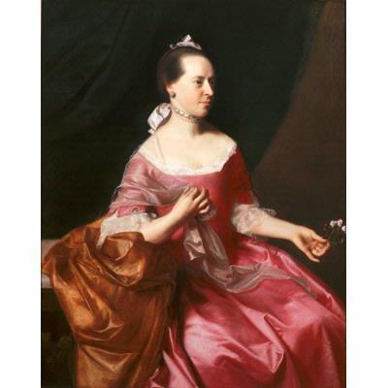
Details
- Title: Portrait of Mrs. Joseph Scott
- Creator: John Singleton Copley
- Date: ca. 1765
- Location: Newark Museum (United States - Newark, New Jersey)
- Physical Dimensions: w40 x h50 in (Image)
- Provenance: Purchase 1948 The Members' Fund
- Type: Painting
- Rights: http://www.newarkmuseum.org/terms.html
- External Link: Newark Museum
- Medium: Oil on canvas
The portrait of
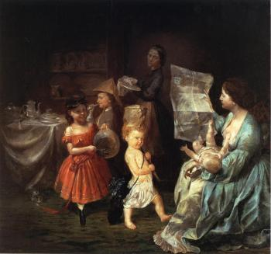
Details
Title: The War Spirit at Home: Celebrating the Battle at Vicksburg
Artist: Lilly Martin Spencer
Dates: | 1866
Location: | Newark Museum (United States - Newark, New Jersey)
Dimensions: | Height: 76.2 cm (30 in.), Width: 83.19 cm (32.75 in.)
Medium: | Painting - oil on canvas
The portrait of
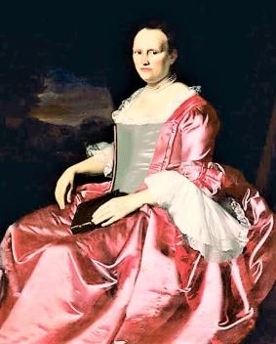
Details
Title: Portrait of Elizabeth Allen Stevens
Artist: John Singleton Copley
Date: ca. 1757
Location: Newark Museum (United States - Newark, New Jersey)
Physical Dimensions: w40 x h50 in (Image)
Provenance: Purchase 1948 The Members' Fund
Type: Painting
Rights: http://www.newarkmuseum.org/terms.html
External Link: Newark Museum
Medium: Oil on canvas

List of Collections from Walsh Library
The material from the library includes books, archival materials, manuals, periodicals, photographs and oral history recordings. For instance, a recent search restored 1787 edition of Thomas Jefferson’s notes about Virginia State. The edition provides more information about America’s founding fathers. It serves as the first English language edition of the text. The copy has been held by the archives and special collection centre which also has fold-out maps and table, frequently removed from this type of work. The book requires good reservation since it has lasted for 230 years

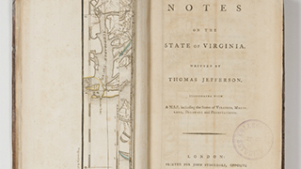
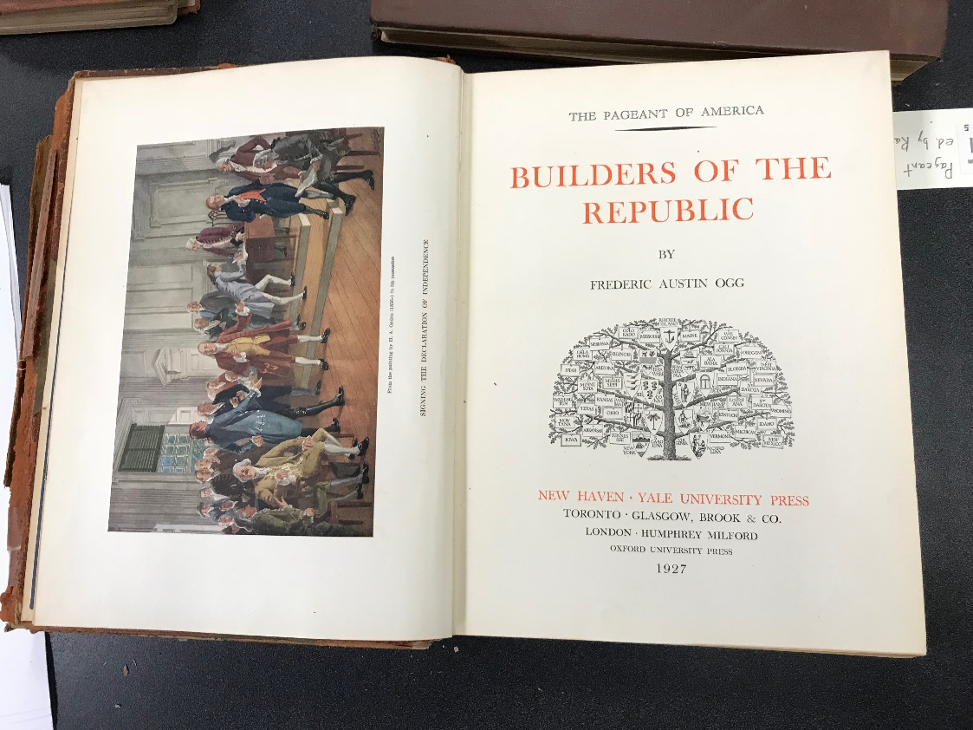

Manuscripts
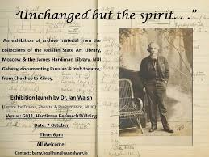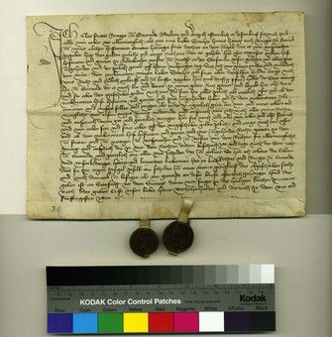

The manuscripts brings out the past history where books were not available. They were used to deliver important facts. Some were used to store details of various treatr
Books and other writen documents
The documents above were found during the searches in the archival collection which include Boston Archdiocese, the college of the Holy Cross and Archivum Romanum Societis Lesu

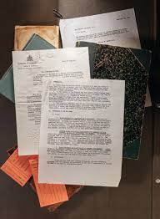

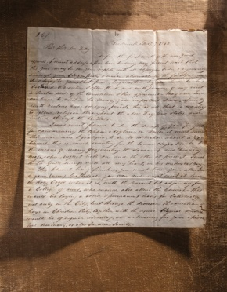
Letter from John McElroy, SJ, to Bishop Benedict Fenwick, SJ, two pages, 8 x 9.75 inches, handwritten, ink on paper, Boston Archdiocesan Archives. Throughout, click images to enlarge, and click again to zoom in.
Photographs from the Library
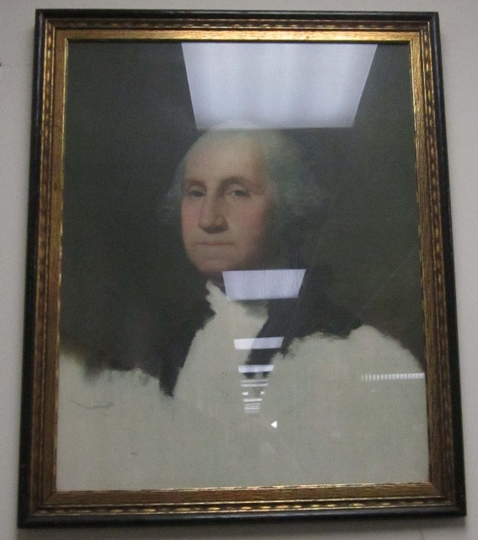
Portrait of Gilbert Stuart’s work illustrating his portrait talent
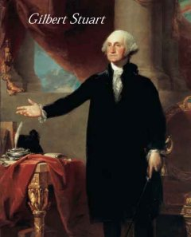
Portrait of Benjamin Green, 1756

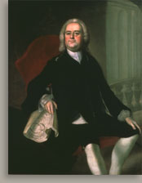

Collections from the Video
Use of ancient dhows by use guys like Christopher Columbus across Pacific Ocean. The voyages led to discovery of America. These voyages resulted to American colonization where Churches replaced the temples. The video also addresses Island people living in the forest who use trees to make canoes. The video shows some of the artifacts of Indians digging gold and silver

